SENSES: A Journey Through Brian’s World

Sight:

Directions:
- Pick one of the images at this station and write a paragraph about that image.
- Your paragraph should use lots of descriptive language (strong adjectives) that deal only with sight.
- Write about what you see including setting and the figure in the picture if there is one.
- You can make inferences about the setting and the animal.

My example:

The squirrel stands perched on a cracked, gray rock. The sharp claws on one of his paws digs into the stone as the other paw rests lightly on the stone’s surface. His speckled brown fur stands on end as he arches his back and opens his mouth wide to bear his two fang-like front teeth and berry red tongue. His beady eyes stare straight ahead to scan the forest around him. His tail, pressed flat to the rock, steadies him in his preparation to pounce.

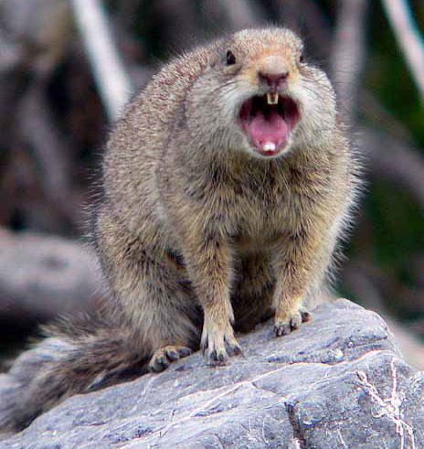

Your Image number________

Your Sight Paragraph:
Sound:

Directions:
- Listen to each of the four sounds I have pulled up on the computer screen.
- When listening to the sounds, close your eyes.
- Play the sounds as many times as you need to.
- Try to identify what animal each sound comes from.

Sound 1:

Sound 2:

Sound 3:

Sound 4:

- Visit the following website: http://www.canadawilderness.com/eco_wildlife.htm
- Read each of the animal squares aloud. Alternate the reading between partners
- List five new interesting facts you learned about these animals

New Facts:

1.

2.

3.

4.

5.

Smell:

Directions:
- Identify each smell
- Smell is the sense most strongly connected with memory. Some of Brian’s strongest memories from home are linked to meals and smells. What memories come to mind when you smell each of these objects?
- Write a short vignette in the first person about one of the memories that one of the smells calls up.

Identify Smells: Identify a memory:

1.

2.

3.

4.

Vignette:

Smell Number___________

Taste:

Directions:
- There are five different cups of jelly beans. Select two jelly beans from each cup.
- Try to identify the flavor of each jellybean

Jelly Beans:
1.

2.

3.

4.

5.

- Select one of the flavors
- Describe the setting in which you might find this food/flavor
- Compare and contrast that setting with the one Brian is in (The Canadian Wilderness)

Flavor Number_______

Setting:

Broad---------------------------------------------------------------------------------------→Specific

Touch:

Directions:
      - Identify all four items

1.

2.

3.

4.

      - Select one of the items and pinpoint a scene in the book in which Brian touches the same/same kind of item.
      - Write down the page number that you find this interaction on.
      - Illustrate that scene.

Item_________ Page Number__________ Scene_________________________

Illustration:

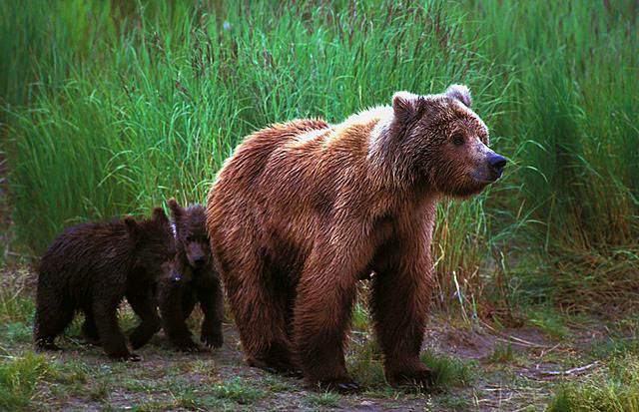
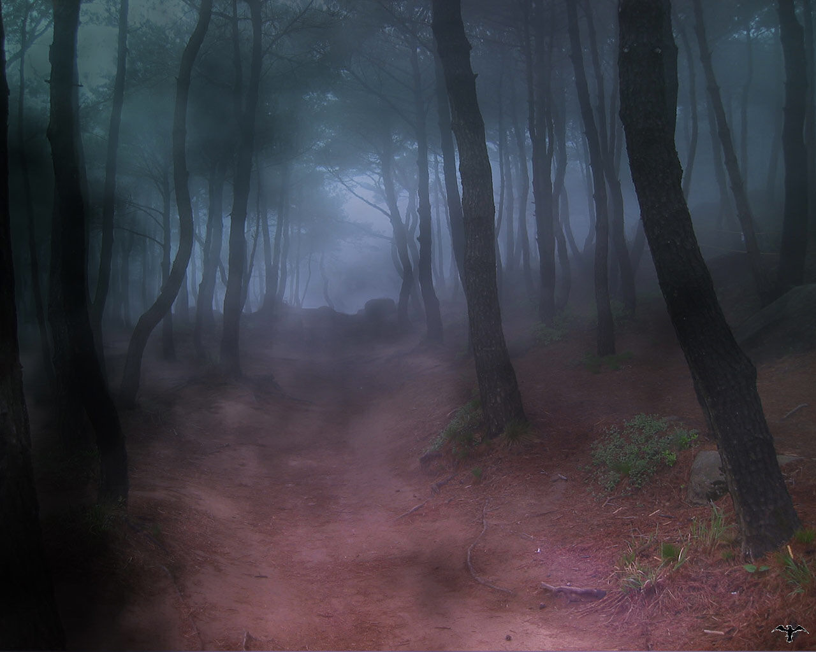
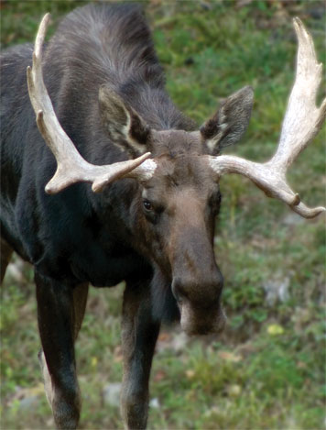
REFLECTION

- How was your experience during this activity similar to Brian’s experience?

- How was your experience during this activity different from Brian’s experience?

- Why are Brian’s senses so important when he is in the wilderness? What specific things does he stand to gain or lose through them?

- In what ways does Brian utilize his different senses in chapter 15? Pick one sense and describe the moment in this chapter that he uses it.

