Stephanie Palmieri
7th/8th Grade Language Arts: Summerbridge
Artemis Fowl
Lesson 14: Monday 7/11/11
45 mins

Unit Title:
Artemis Fowl

Lesson Title:
Point of View

Objectives:
- Students will identify the job of a pronoun in a sentence and identify the differences between commonly misused homonyms. [Knowledge, Comprehension]
- Students will define point of view and illustrate a scene from one of two main character’s perspective. [Knowledge, Comprehension, Application, Analysis, Synthesis, Evaluation]
- Students will identify and analyze four main characters’ perspective on the protagonist. [Knowledge, Comprehension, Application, Analysis, Synthesis, Evaluation]

Instructional Procedure:
- Warm Up: (10 mins)
  - Today we are going to be talking all about point of view. Before we get to that we are going to kick it old school with a School House Rock pronoun video: http://www.youtube.com/watch?v=yg9MKQ1OYCg
  - After watching the video, can anyone tell me what a pronoun does? What is its job in a sentence?
    - To take the place of a noun, proper noun, or other pronoun.
    - Keeps a piece of writing from being too confusing. Keeps it uncomplicated.
    - However, too many pronouns can be a bad thing. Why do you think this might be the case?
      - If we overuse pronouns it is difficult for the reader to follow our thought process. It might be difficult for the reader to tell who or what we are talking about in our writing, so we must be sure to clarify from time to time.
  - Commonly misused (homonyms) words (from the video):
    - They’re, their, there
    - Are, our
    - Its, it’s
    - Your, you’re
    - To, too, two
- Point of View Intro: (5 mins)
  - Can anyone tell me what point of view is?
    - The perspective from which a story is being told.
    - First, second, third (limited/omniscient) person point of view
  - Point of view affects how we see and understand:
    - The setting
    - Each character
    - Each conflict
  - Handout:
    - Go through each one and clarify
- Illustration (15 mins)
  - Let’s go back and look at the first time Artemis and Holly interact. On page 74 Butler and Artemis approach Holly. They shoot at her and she realizes that they know way too much about fairies. They shoot her with a tranquilizer dart and kidnap her.
  - Have class count off by 2’s. 1’s will illustrate the scene from Artemis’s perspective. 2’s will illustrate the scene from Holly’s perspective.
    - Read 75-77 aloud
    - As I read, pay attention to how your character is acting in the scene. What might they be seeing as the scene unfolds?
    - Illustration will be done on a sheet with a large figure 8ish drawing on it, which is there to simulate looking through a character’s eyes.
  - Setting:
    - Where are they?
    - What else is around?
    - What is the atmosphere like?
    - What is the mood or tone of this passage?
- Understanding Artemis Worksheet (10 mins)
  - Point of view also gives us insight into how other characters view Artemis. This story is narrated in third person omniscient. What are the clues that help us to know it is in this point of view?
    - The prologue
    - We get information from inside each character’s brain.
    - We get a more complete sense of the story because we see it from all different sides.
  - How do we think about Artemis? How do the other four main characters think about Artemis.
    - In the box around Artemis’s picture, fill in adjectives you use to describe him.
    - In the boxes around the outside, write down how other characters describe Artemis and how they feel about him.
- Wrap Up: (5 mins)
  - Share for each box with class
  - Why do you think it is important to know and understand how other character’s perceive the protagonist and each other?
- Homework:
  - Finish the Artemis point of view worksheet
  - Read 143-160

Assessment:
- Pronoun video discussion
- Homonym discussion
- Illustration
- Perspectives worksheet

Materials:
- Youtube video
- POV worksheet
- Artemis perspectives worksheet
- Paper
- Markers
POINT OF VIEW:
Who is telling the story and How is it being told?

Point of View | First Person | Second Person | Third Person Limited | Third Person Omniscient
Description | -The narrator is a character in the story  -Story is told through the voice of one specific character  -The character uses first person pronouns like "I" “me” and “my” when narrating the story.  -Reader gets one side of the story/one perspective (The narrator’s) | -Author uses “you” and “your” in the narration to address readers directly. | -The author is the narrator of the story.  -The story is being seen through the eyes of one particular character.  -The narrator uses the pronouns “he” or “she” when telling the story.  -The narrator reveals only one character's inner thoughts. | --The author is the narrator of the story.  -The story is told by an all-knowing narrator  -The narrator supplies more information about all the characters’ thoughts, feelings, and events than any one character could know.
Reader’s Job | -Pay close attention to the actions and words of a first person narrator to determine his objectivity because as readers, we are shown only one side of the story.  -Think about other character’s perspectives | -This style is rare so pay attention to how you are being addressed as the reader. What does the author want you to know? | -Pay close attention to the actions and words of the one character that the story is being told through. The information about other characters will be viewed through only this character’s eyes.  -Think about other character’s perspectives. | -Take all character’s perspectives into account and fit them all together.

Notes:

Butler Holly

Root  Foaly

Stephanie Palmieri
7th/8th Grade Language Arts: Summerbridge
Artemis Fowl
Lesson 15: Tuesday 7/12/11
45 mins

Unit Title:
Artemis Fowl

Lesson Title:
Analysis

Objectives:
- Students will predict the way that the major characters’ perspectives on and opinions of Artemis might change throughout the rest of this book and the series by using clues from the text. [Knowledge, Comprehension, Application, Analysis, Evaluation]
- Students will analyze short scenes from last night’s reading by answering guided reading questions. [Knowledge, Comprehension, Application, Analysis, Synthesis, Evaluation]
- Students will identify presentation techniques and present their analysis to the class. [Knowledge, Comprehension, Application, Analysis, Synthesis]

Instructional Procedure:
- Warm Up: (10 mins)
  - Artemis perspectives worksheet
    - Share answers we did not get a chance to go over yesterday
    - Prediction: how do you think these perspectives on Artemis might change throughout the rest of the book and the series?
    - What clues helped you to make this prediction?
  - Major plot events that happened in this section/a concise summary of what happened.
- Analyzing Artemis Scenes (15 mins)
  - Students will be split into pairs. Each pair will analyze a scene and present it to the class.
    - When answering the questions focus on what the main character(s) in that passage is/are doing
  - I will copy each passage for all of the students so they can talk to the text while working.
  - Scenes:
    - Page 152: “Artemis buttoned – Determined one”
    - Page 156: “Root said nothing – unorthodox action”
    - Page 158: “Root slammed – plasma screen”
    - Page 159: “I’d advise – break a few”
- Mini-presentations (15 mins)
  - Before we present can anyone tell me some things that we want to do when speaking in public/speaking to a group?
    - Looking up/Eye contact around the room
    - Steady/no fidgeting
    - Loud, clear voice – project
    - Intonation/no monotone
    - No playing with hair
  - Pairs will
    - Describe the scene
    - Note actions of characters and themes present
    - Why does author include this section?
  - Comments from other students
- Wrap Up: (5 mins)
  - Using what we learned about Artemis and Root today, what similarities do you see between either character and yourself or either character’s actions/decisions and your own in real life?
- Homework:
  - Read 161-173
  - Write down 3 facts about Mulch and 3 of his character traits

Assessment:
      - Warm Up
      - Analysis in pairs
      - Presentations
      - Wrap Up questions

Materials:
- Guided reading worksheet
- Passages

Guided Reading: Analysis

Describe the scene
How is the character described by the narrator?
What actions is the character or characters taking?
Are any of the themes we discussed present in this passage? Which one(s)?
Why do you think the author included this scene? What is the author trying to tell us about this character?

Stephanie Palmieri
7th/8th Grade Language Arts: Summerbridge
Artemis Fowl
Lesson 16: Wednesday 7/13/11
45 mins

Unit Title:
Artemis Fowl

Lesson Title:
Analysis

Objectives:
- Students will identify character traits of a new character and make inferences and predictions about that character and his role in the rest of the story. [Knowledge, Comprehension, Application, Analysis, Evaluation]
- Students will write stories about two famous characters and a setting using a conflict we learned about in class. [Knowledge, Comprehension, Application, Analysis, Synthesis]

Instructional Procedure:
- Warm Up: (10 mins)
  - Students will write their facts and character traits for Mulch on the side board under the appropriate character.
  - Concise summary of the section
  - What do we know about Mulch? What inferences can we make about him?
  - Why introduce this character so late in the book?
  - Predictions: what role do you think he will play in this story? What is his purpose?
    - What kinds of trouble might he get into or cause based on what we know about him from this section?
- Intro Conflict: (7 mins)
  - Can anyone tell me what the literary term conflict means?
    - The drama, the trouble, the action
    - A character, likely the protagonist, has altercations with him or herself, other characters, nature, society, fate, machines, etc.
  - Conflict description sheet
- Conflict Activity: (20 mins)
  - I will spread out a pile of pictures on the floor → characters and settings
  - Students will pick a total of 3 pictures (2 characters and 1 setting).
  - Students will create a short one paragraph story using the pictures they selected. The short story must include one type of conflict that we discussed today in class
    - The conflict should be based on inferences you make about the character in the picture. For example, Walle looks sad so in your story something bad might happen to him. Bugs in on the baseball field, so the conflict might have something to do with baseball
- Wrap Up: (8 mins)
  - Share stories aloud
  - What type of conflict did he or she use in his or her story?
    - Does it remind you of any conflicts in Artemis Fowl?
- Homework:
  - Read 173-187
  - Conflict worksheet
    - Two that are in the chapter
    - Predict two potential conflicts that might happen in the next section
      - What are the clues

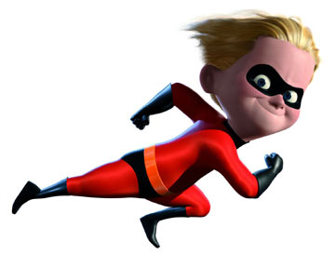
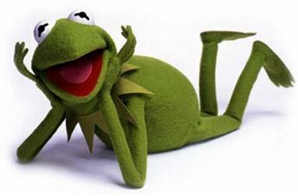
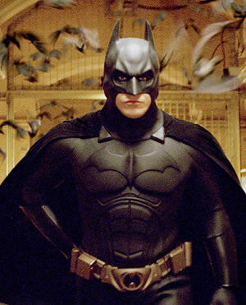


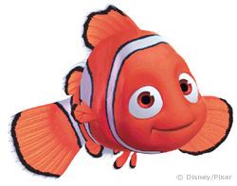
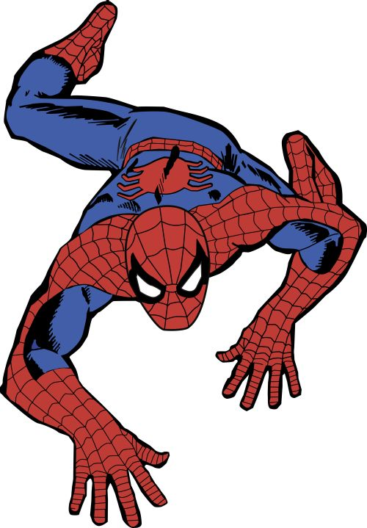
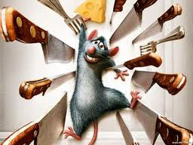

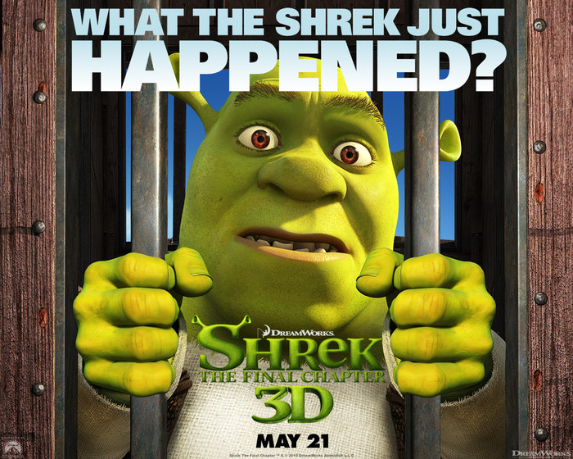
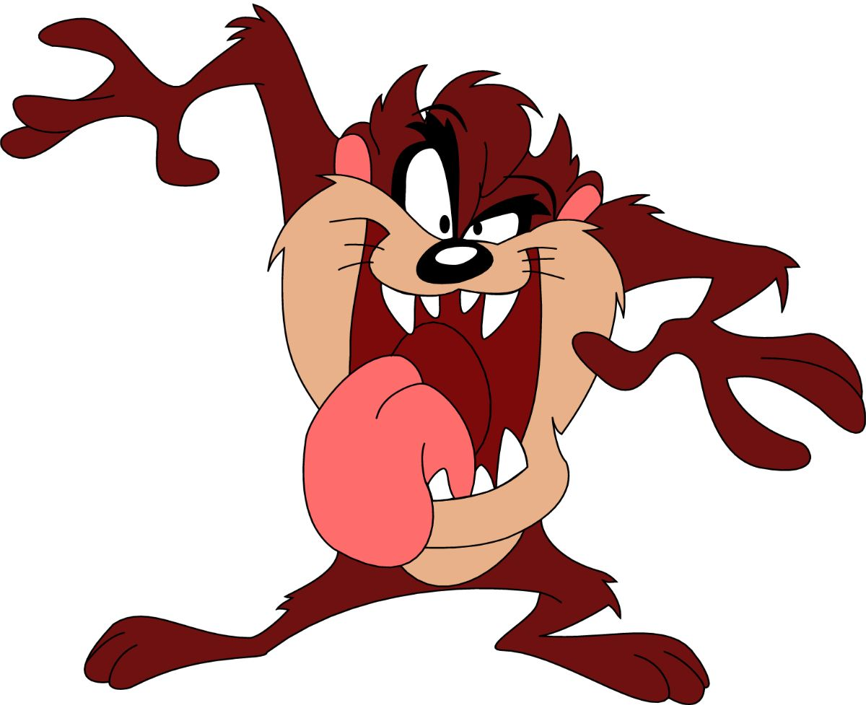

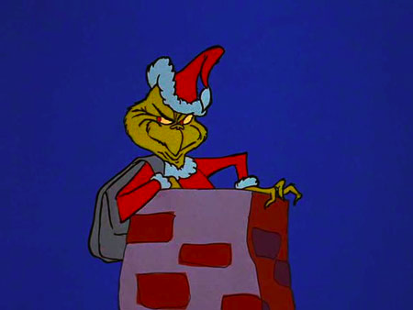
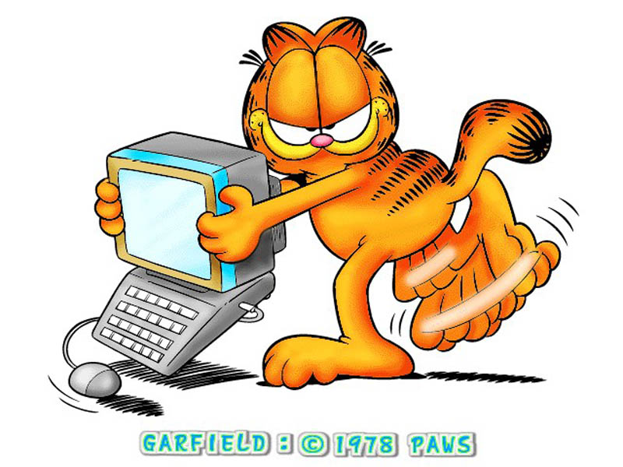
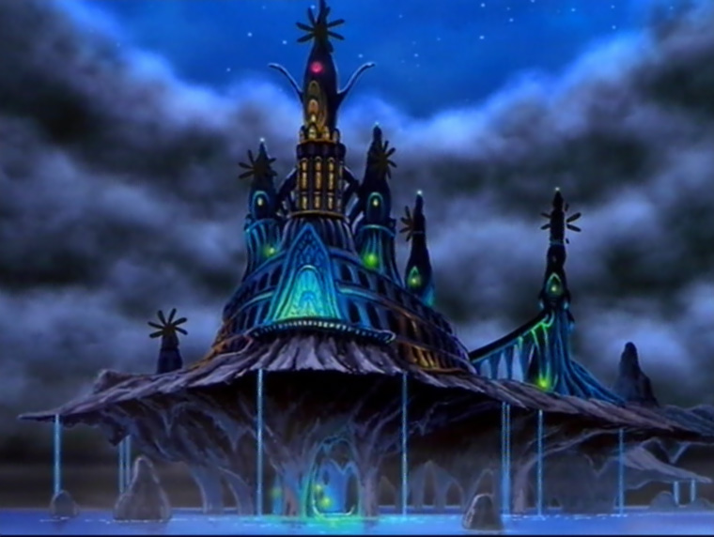
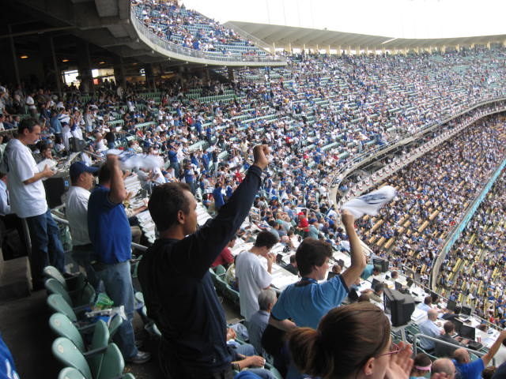




Character versus Character  One character vs. another character  Conflict might be physical  Conflict might be verbal  Conflict might be one time or recurring  Example:  Harry Potter vs. Voldemort - (Harry Potter Series) | Character versus Self  Internal conflict  An internal conflict is a good test of a character’s values  Ask yourself:  What is the character struggling with?  Why?  What does he or she decide to do?  Example:  Angel/Devil on shoulder
Character versus Nature  Character has a run-in with the forces of nature.  Tests the limits of a person’s strength and will to live.  Example:  Dorothy vs. The Tornado (The Wizard of OZ) | Character versus Society  Character challenges the customs everyone else lives by  One character is in opposition of a large group of people  Example:  Hannah vs. The popular kids at school (Hannah Montana)

Notes:

Conflict in Artemis Fowl
Type of conflict | What Happens?/Page #
Character vs.
Character vs.
Predict conflicts in the next section | What do you think will happen?  What are the clues?
Character vs.
Character vs.

Stephanie Palmieri
7th/8th Grade Language Arts: Summerbridge
Artemis Fowl
Lesson 17: Thursday 7/14/11
45 mins

Unit Title:
Artemis Fowl

Lesson Title:

Objectives:
- Students will identify the types of conflict that appeared in the section they read for homework and predict what potential conflicts might arise in the next section. [Knowledge, Comprehension, Application, Analysis]
- Students will write a summary of the section we read for homework in the first person as one of the characters that appeared in this section using a RAFT as a guide. [Knowledge, Comprehension, Application, Analysis, Synthesis, Evaluation]

Instructional Procedure
- Warm Up: (10 mins)
  - Section summary
  - Share conflict homework sheet
    - Root vs. Mulch (p. 181)
      - What does this conflict tell us about the relationship between these two characters?
      - What do they call each other?
      - How do they speak to each other?
    - Artemis vs. Fairies
    - Artemis vs. Root
    - Artemis vs. Holly
    - Artemis vs. Foaly
    - Predictions/Clues
- RAFT/Section Summary (25 mins)
  - RAFT example
  - Pick one of the characters that appeared in this section:
    - Artemis, Foaly, Root, Butler, Holly, Juliet
  - Write a paragraph in the first person point of view as that character. The paragraph should be a summary of what happened in that section as that character experienced/witnessed it.
    - Think about how that character experienced conflict in this section.
      - What did he or she think about it?
      - How did he or she feel about it?
      - What might he or she have wanted to do or say but didn’t?
  - Share with partner
  - Share with class
- Wrap Up: (10 mins)
  - I will read the last page of this section (187) aloud.
  - Predictions: what conflicts do you think might happen next?
    - You can reference your homework sheet from last night or change your mind based on what we discussed in class today.
- Homework:
  - Read p. 187-200
  - 5 Post it notes → mark places in the section where a theme we have been tracking appears.
    - Make sure that a brief one sentence description of the scene is on the post it, the theme, and the page number

RAFT

R: Role (Who are you?)

A: Audience (To whom are you writing?)

F: Format (What form will your writing assume?)

T: Topic (What are you writing about?)

EXAMPLE:

Role | Audience | Format | Topic
Cell phone | My owner | A letter | My treatment

Dear Owner,

Lately I have been feeling neglected and under appreciated. I make calls and texts for you everyday but then you throw me around and drop me on the floor. My cover is cracked and scratched and it is embarrassing when I am around all the other shiny, new looking phones. I also feel like it isn’t fair that you only pay attention to me when you need me. As soon as you are done with a text or a call you shove me into your bag and I don’t see you or the daylight again for hours. It gets so hot and stuffy inside your bag and I just wish that sometimes you would take me out and let me breathe in some fresh air. I hope that you can listen to what I have to say and take better care of me in the future.

Sincerely,
Your Phone
RAFT

R: Role (Who are you?)

A: Audience (To whom are you writing?)

F: Format (What form will your writing assume?)

T: Topic (What are you writing about?)

Role (Character) | Audience | Format | Topic
 | Self | Journal entry in first person | What happened in the section

Stephanie Palmieri
7th/8th Grade Language Arts: Summerbridge
Artemis Fowl
Lesson 18: Friday 7/15/11
45 mins

Unit Title:
Artemis Fowl

Lesson Title:
Theme Analysis

Objectives:
- Students will recall the major themes we have been keeping track of while reading and identify ways in which these themes are related to power and to what characters gain and lose. [Knowledge, Comprehension, Application, Analysis]
- Students will assess the author’s purpose for using particular themes at particular moments in the section we read for homework. [Knowledge, Comprehension, Application, Analysis, Evaluation]
- Students will evaluate a passage from the text by analyzing the author’s use of theme in that passage and by writing a paragraph addressing what the student has learned from the passage. [Knowledge, Comprehension, Application, Analysis, Synthesis, Evaluation]

Instructional Procedure:
- Warm Up: (10 mins)
  - Theme Review:
    - What are the major themes we have been tracking throughout the summer?
      - Eyes
      - Silence
      - Language
      - Technology use
      - Names
      - Child to Adult
    - How are these themes related to power? What characters gain or lose power in this section? How?
- Theme Collection: (10 mins)
  - I will have all of the themes up on the board in columns.
  - Students will take the 5 post its that they used last night to track the theme. They will put it under the appropriate category.
  - We will gather around that board with chairs, pencils/paper, books and share some of the moments.
    - Why do you think the author chose to insert this theme at this moment?
    - What seems particularly important about this moment?
      - Does a character gain or lose something in this scene?
      - Is there a major conflict happening in this scene
    - Students will take notes on the theme tracker note sheet as we talk. They can use this sheet as a guide for the next activity.
- Theme Analysis: (20 mins)
  - Students will select one of the themes that they found last night. Students can use a theme that we discussed in class today.
    - What is the theme of the passage you picked?
    - What characters are in the scene?
    - What is the conflict?
    - What do the characters gain or lose in this scene?
  - Students will write a paragraph that answers a prompt asking them what the author wants readers to learn after reading the passage they analyzed.
- Wrap Up: (5 mins)
  - Share some of the ideas about knowledge gained from the passages read.

Assessment:
- Theme review
- Themes on board/note taking
- Theme analysis questions and paragraph

Materials:
- Theme worksheets

Theme Tracker

Theme | Scene Description | Page Number

Theme in the passage _______________________________ Page Number______________

What characters are in the scene?

What is the conflict? | Character vs.  One sentences description:
What do the characters gain or lose in this scene?  Character_______________________  Character_______________________ | Gain:  Lose:  ____________________________________________  Gain:  Lose:
Theme Analysis
Theme Analysis

Write one paragraph that answers the following prompt:

What does the author want us to understand now that we have read this passage? What does he want us to learn about life?

Think carefully about:
- What characters appear in this passage
- What he or she gains or loses
- How the theme affects that gain or loss
Example → Theme in the passage: Silence Page Number: 190

What characters are in the scene? | Juliet
What is the conflict? | Character vs. Holly  One sentences description:  At Artemis’s request, Juliet goes to check on Holly, who has regained her magic and mesmerizes Juliet in order to escape.
What do the characters gain or lose in this scene?  Character: Juliet  Character: Holly | Gain:  Lose: Control over Holly and self. She is silenced  ____________________________________________  Gain: Power over Juliet and Artemis by regaining her magic. She mesmerizes Juliet using eye contact and magical language.  Lose:

The author might want the readers to understand that asserting and maintaining power over others is achieved through eye contact. Eyes are often called the window to the soul. When Holly is able to look Juliet right in the eyes, she is able to use the Mesmer on Juliet. In this scene not only is Juliet silenced by the apparent disappearance of Holly (now shielding due to the restoration of her magic), but Holly also gains power through her use of language, which she combines with eye contact. The author might also want the readers to understand that in life, it is important to be one’s own advocate. Juliet is under Artemis’s orders and loses control when he can no longer communicate with her. On the other hand, Holly, alone in her cell, devises a plan to restore her magic and escape. She is her own boss and perseveres through pain in order to escape and regain her lost power.

